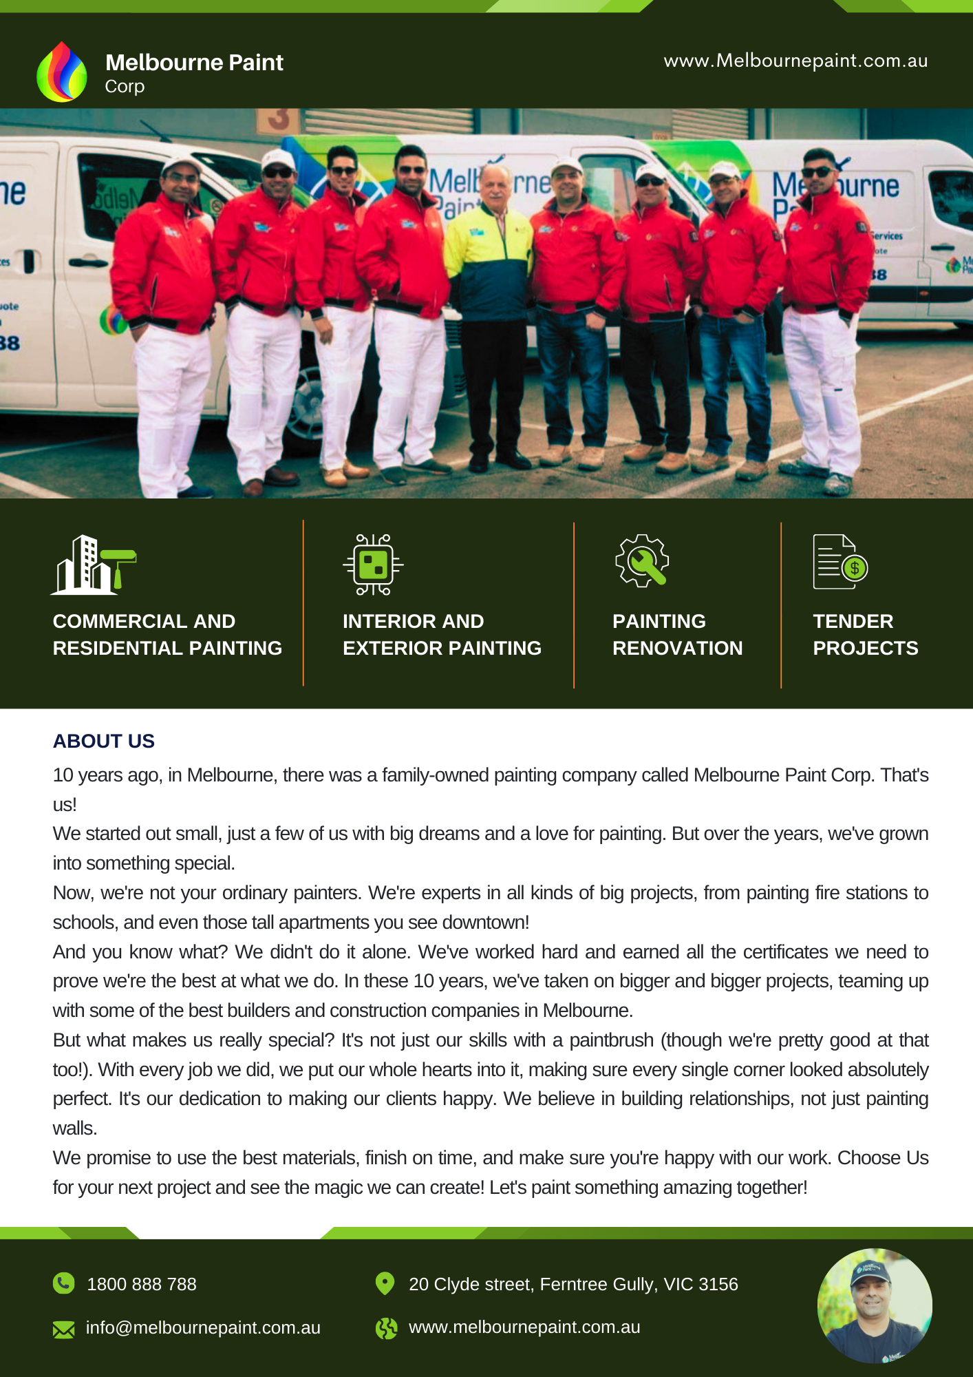

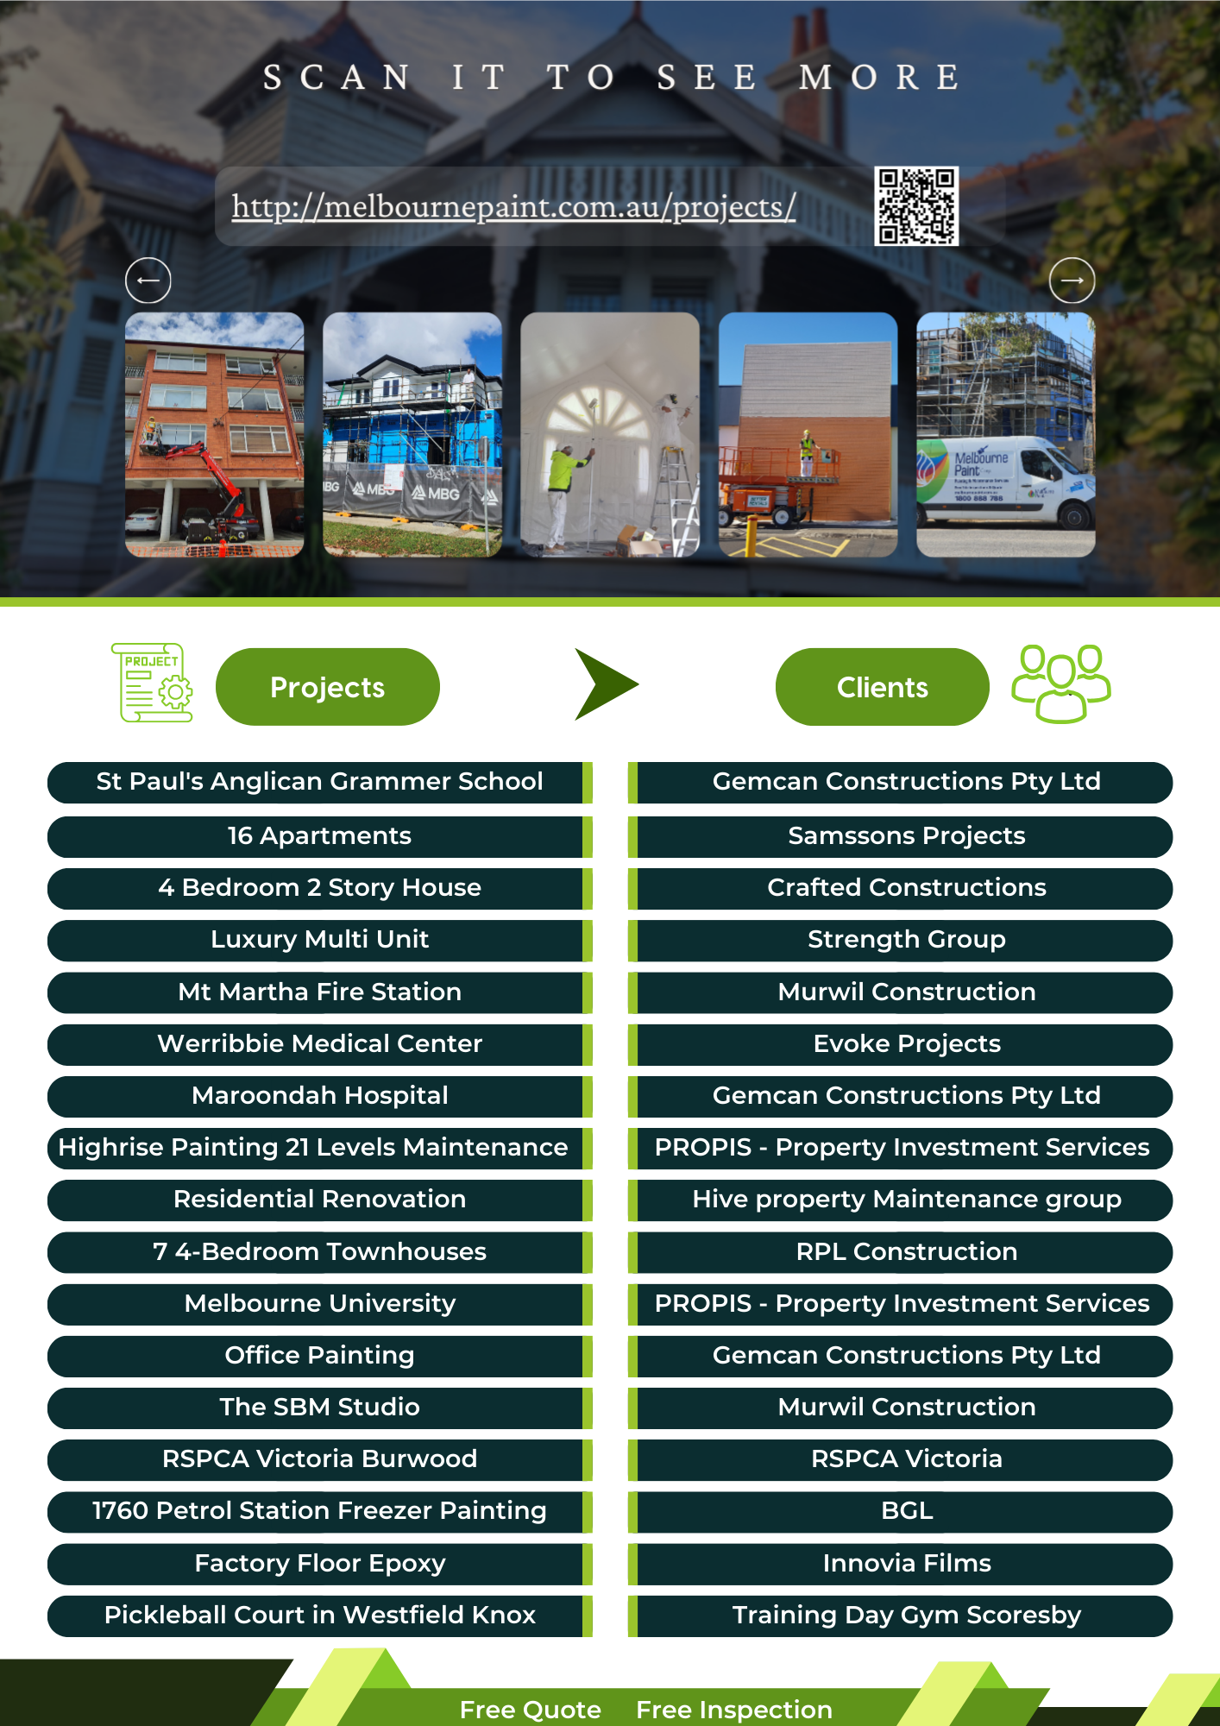

|  |  |  |  |
| --- | --- | --- | --- |
| **To:** | [Name] [Family] | **Quotation No:** | [QuoteNo] |
| **Business/Company:** | [Company] | **Quotation Subject:** | [JobAddress] |
| **ABN:** | [ABN] | **Issue Date:** | [IssueDate] |
|  |  | **Valid until:** | [ValidDate] |

**Scope of works:**

|  |  |  |  |  |
| --- | --- | --- | --- | --- |
| [T1] |  |  |  |  |
|  | **Subtotal** |  |  | $ [*SumColumn] AUD |
|  | **10% GST** |  |  | $ {[FE@2]*0.1} AUD |
|  | **Total** |  |  | $ {[FE@2]*1.1} AUD |

**Inclusions/Assumptions:**

[Inclusion]

**Exclusions:**

[Exclusion]

**Preparation & Finish:**

[Preparation]  
[Finish]

**Notes:**

20.000.000 public and product liability insurance

Work cover insurance

Accredited company by Dulux group

Qualified, full vaccine painters

Industry standard AS/NZS 2311:2017  
[Notes]

**%30 deposit required to book a fixed commencement date**

For further information or any questions please call Arash Yazdi, 0405-544-997

**This is a payment claim made under the building and construction industry security of payment Act 2002.**