Testing of 10938

Upload some file that's known to be ingestable (Stata, CSV ... doesn't matter). Populate the description field in the file metadata. Publish the dataset.

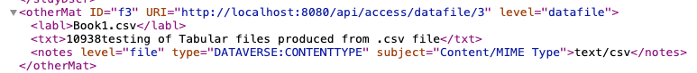

Testing with max desc file metadata:

Stata File Test

