Under the Wave off Kanagawa

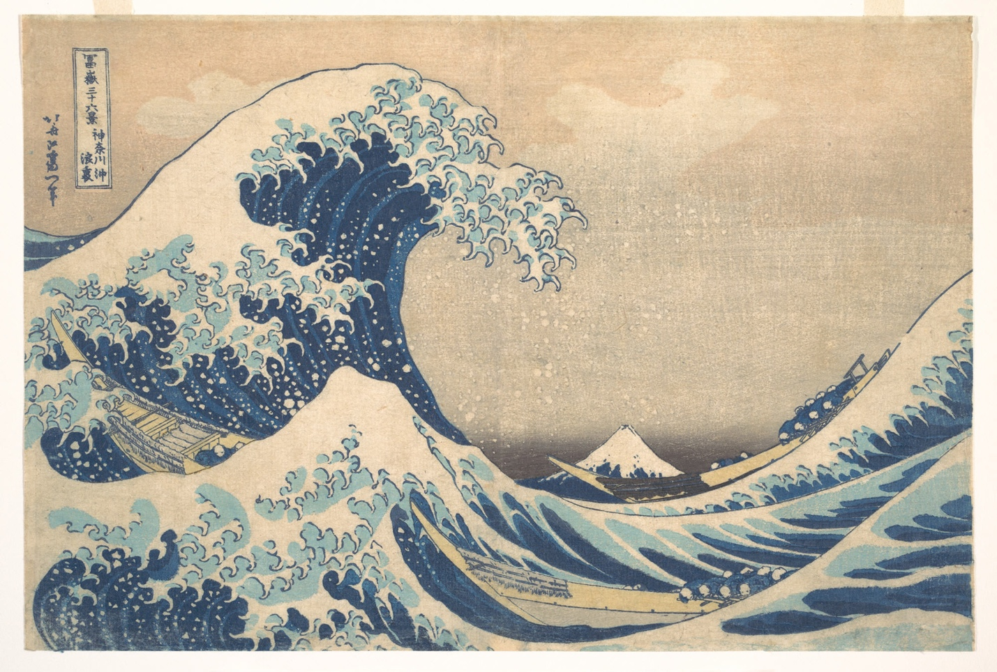

Also known as The Great Wave

