It seems to be text filter -> enabling checkbox Regexp -> didn’t work.

However, I am expecting to display/read the messages from logs and display in UI instead of filtering and reading the entire logs.

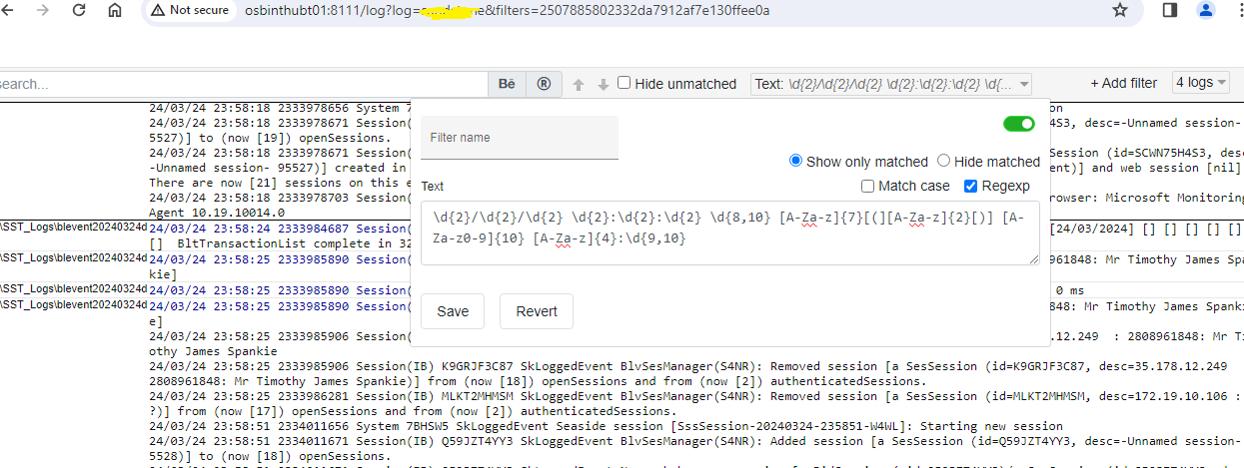

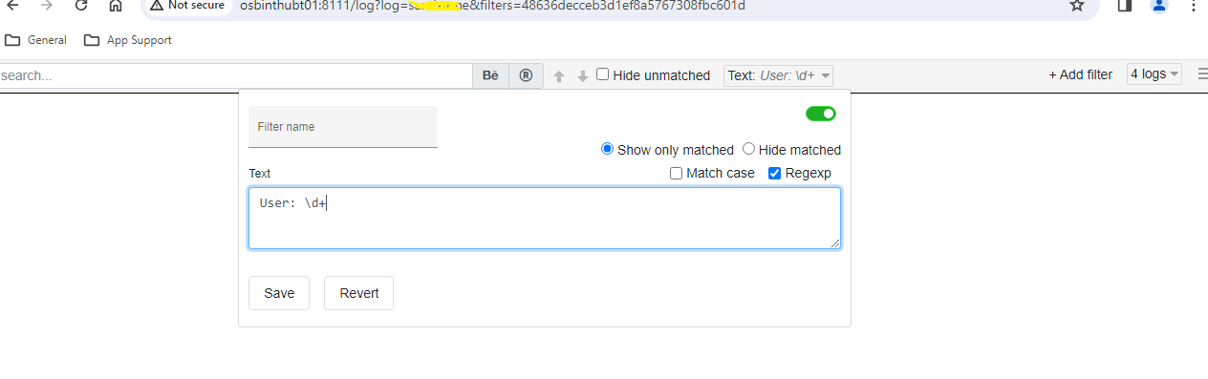

My requirement is to display or read only the below messages highlighted in font colour (blue) pattern messages and display in UI.



In other words, the below based pattern messages should be read/display in UI from logs prior to filtering from logviewer UI.

24/03/24 23:12:40 2331240937 Session(IB) BVFS3JYDVF User:2707715134

I don’t want to read the below messages from logs or don’t want to display in UI.

