Installation steps I followed in google cloud :

Step1 :Installed the articulate latest file in c drive and unzip it.

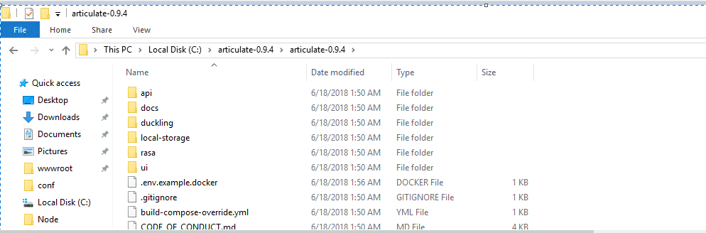

Step 2:

Revised changes in docker-compose.yml

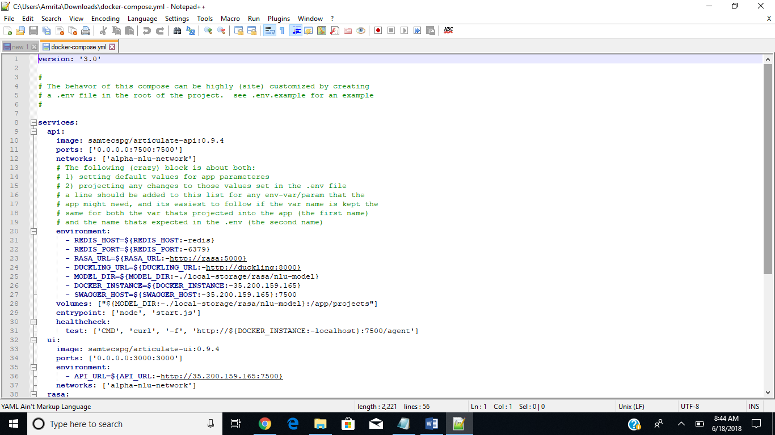

Step 3:

Revised env file

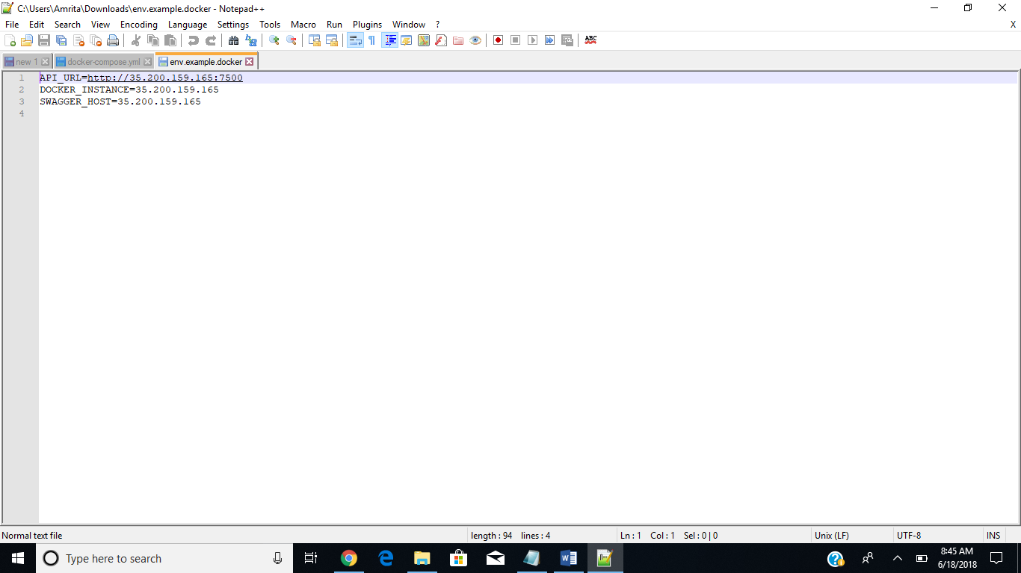

Step4:

Running command docker-compose up.Getting below error.

