My map code values for each class

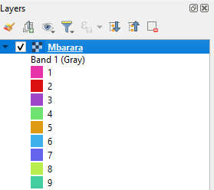

Values(Map_code) appearing in strata areas tab(stratified area estimator)

