971 502.918286 Shenzhen_0c:1f:f3 (YunChen) localhost () ATT 32 Rcvd Handle Value Notification, Handle: 0x0016 (Unknown: Unknown)

0000 c1 01 21 98 01 83 19 64 01 ad 00 ed 00 1a 07 4a

0010 4a 3c 00 e6

c101 49409 cannot understand perhaps some standard report

2198 8600 weight 86.00 kg

0183 387 fat 38.7%

1964 6500 Again, could not correlate with any information (separately 19 -> 25, 64 -> 100)

01ad 429 water 42.9%

00ed 237 Muscle 23.7%

001a 26 Bone 2.6%

074a 1866 Kcal 1866 Kcal

4a 74 Could not correlate

3c 60 Body age

00e6 230 Could not correlate

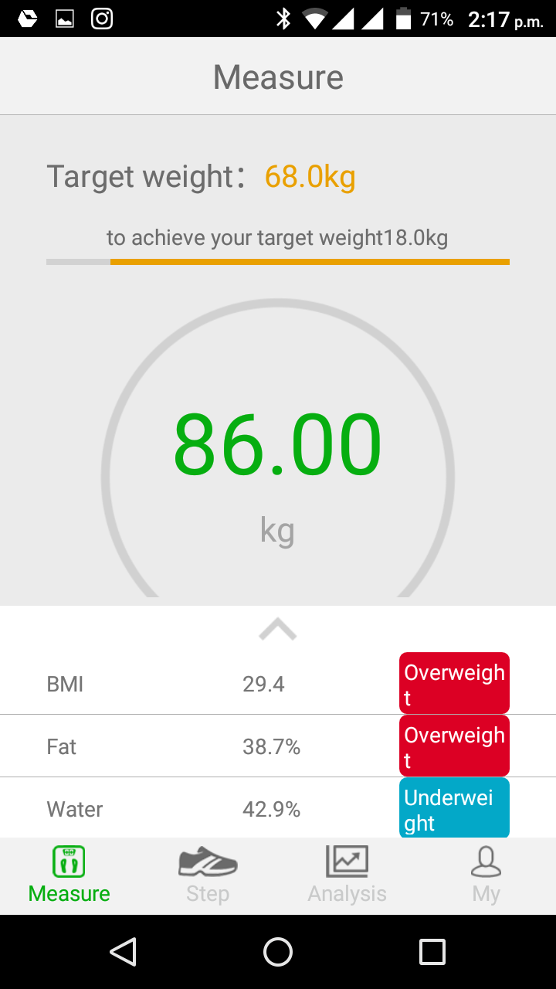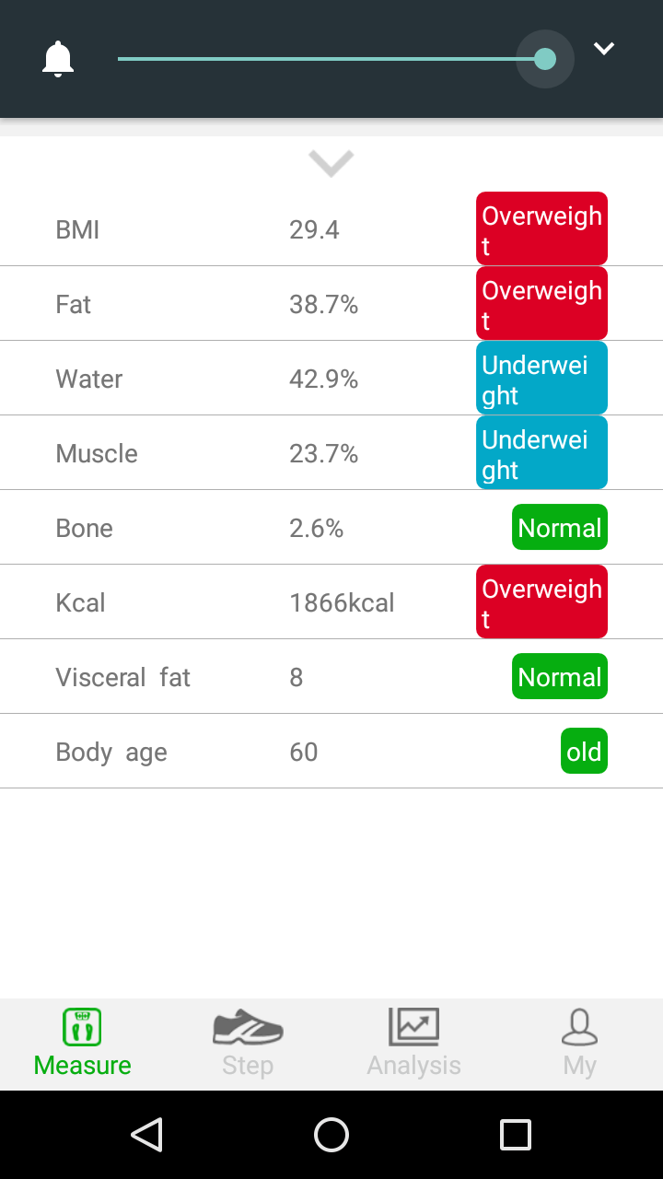

From the above images, it can be seen that except for BMI and Visceral fat, all the information are available in order.

The exact lines from wireshark:

0000 02 02 22 1b 00 17 00 04 00 1b 16 00 c1 01 21 98 .."...........!.

0010 01 83 19 64 01 ad 00 ed 00 1a 07 4a 4a 3c 00 e6 ...d.......JJ<..

More detailed wireshark info is on next page:

Frame 971: 32 bytes on wire (256 bits), 32 bytes captured (256 bits)

Encapsulation type: Bluetooth H4 with linux header (99)

Arrival Time: Jan 17, 2018 14:17:00.498166000 IST

[Time shift for this packet: 0.000000000 seconds]

Epoch Time: 1516178820.498166000 seconds

[Time delta from previous captured frame: 0.004050000 seconds]

[Time delta from previous displayed frame: 0.355514000 seconds]

[Time since reference or first frame: 502.918286000 seconds]

Frame Number: 971

Frame Length: 32 bytes (256 bits)

Capture Length: 32 bytes (256 bits)

[Frame is marked: False]

[Frame is ignored: False]

Point-to-Point Direction: Received (1)

[Protocols in frame: bluetooth:hci_h4:bthci_acl:btl2cap:btatt]

Bluetooth

[Source: Shenzhen_0c:1f:f3 (78:9c:e7:0c:1f:f3)]

[Destination: 00:00:00_00:00:00 (00:00:00:00:00:00)]

Bluetooth HCI H4

[Direction: Rcvd (0x01)]

HCI Packet Type: ACL Data (0x02)

Bluetooth HCI ACL Packet

.... 0010 0000 0010 = Connection Handle: 0x202

..10 .... .... .... = PB Flag: First Automatically Flushable Packet (2)

00.. .... .... .... = BC Flag: Point-To-Point (0)

Data Total Length: 27

[Connect in frame: 810]

[Disconnect in frame: 1079]

[Source BD_ADDR: Shenzhen_0c:1f:f3 (78:9c:e7:0c:1f:f3)]

[Source Device Name: YunChen]

[Source Role: Unknown (0)]

[Destination BD_ADDR: 00:00:00_00:00:00 (00:00:00:00:00:00)]

[Destination Device Name: ]

[Destination Role: Unknown (0)]

[Current Mode: Unknown (-1)]

Bluetooth L2CAP Protocol

Length: 23

CID: Attribute Protocol (0x0004)

Bluetooth Attribute Protocol

Opcode: Handle Value Notification (0x1b)

0... .... = Authentication Signature: False

.0.. .... = Command: False

..01 1011 = Method: Handle Value Notification (0x1b)

Handle: 0x0016 (Unknown: Unknown)

[Service UUID: Unknown (0xfff0)]

[UUID: Unknown (0xfff4)]

Value: c10121980183196401ad00ed001a074a4a3c00e6

c100

0a14 2580

0000

0000

0000

0000

0000

0000

00

00

00df 223